***A.A.GOVERNMENT ARTS COLLEGE, MUSIRI.***

***Affiliated to Bharathidasan University, Tiruchirappalli.***

**NAAN MUDHALVAN PROJECT – III B.SC MATHEMATICS**

**TOPIC:**

***IRevolution: A Data-driven Exploration of Apple's iPhone Impact in India***

***Submitted by***

**TEAM ID: NM2023TMID08517**

**TEAM LEADER:**

ELAVARASAN B : [DD1E9A5E3549CC792A542FEECA51577B]

**MEMBERS:**

1. GOKULRAJ A : [60B0322BD54C3E589EA4DAFC4DD64185]

2. BALASUBRAMANIYAN T : [36EE363466B8882A490445E9144B496A]

3. YOGISHWARAN S : [A8CC54660DC5858BBBE47A83F88AE63]

***INTRODUCTION***

The technology giant that has cornered the market on all electronic types, ranging from computers to phones to tablets: yes, I am talking about Apple. Founded in 1976 in California, United States, Apple has become one of the most well-known companies that exist to date. In 1976 the Apple I, the first computer built by Apple, had a significant influence over the public.

**REFERENCE :**

*Milestone 1: Define Problem / Problem Understanding*

Activity 1: Specify the business problem

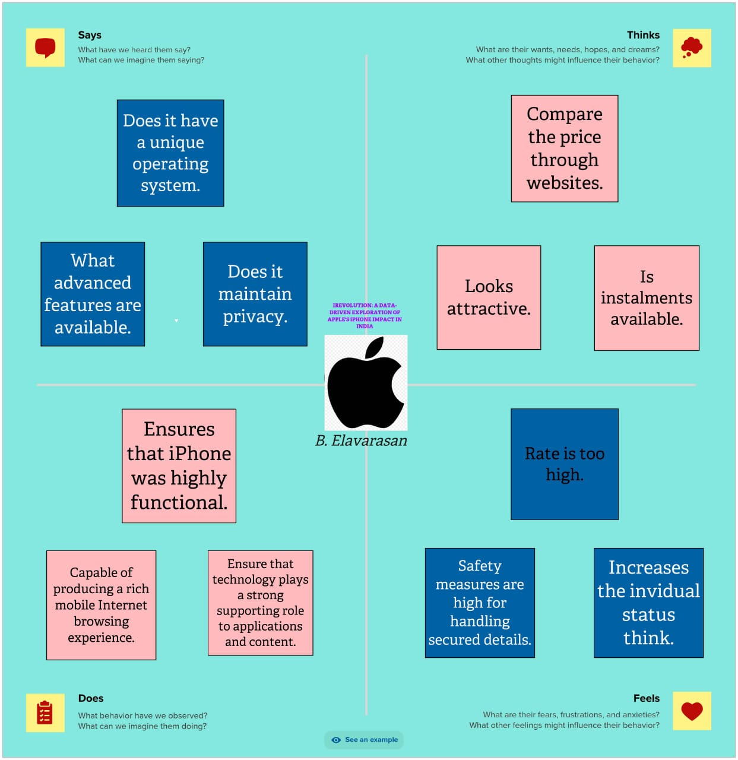

Activity 2: Business requirements

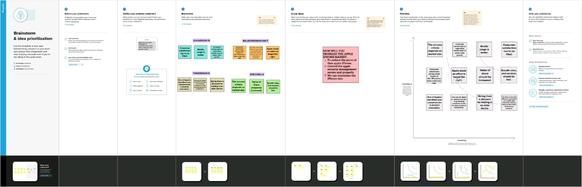

*Milestone 2: Data Collection*

Activity 1: Downloading the dataset

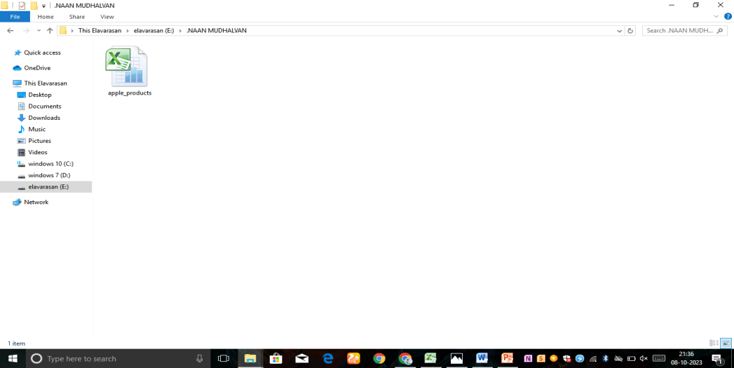

Activity 2: Connect Dataset with Tableau

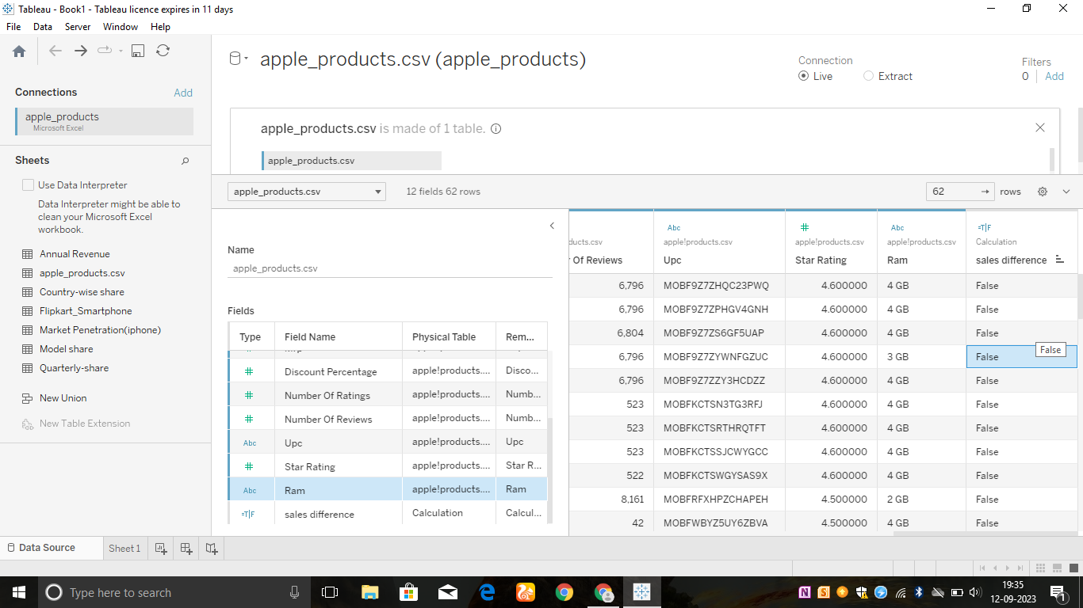

*Milestone 3: Data Preparation*

Activity 1: Prepare the Data for Visualization

This process helps to make the data easily understandable and ready for creating visualizations gain insights into performance and efficiency.

*Milestone 4: Data Visualization*

Data visualization is the representation of data through use of common graphics, such as charts, plots, infographics, and even animations.

Activity 1: Number of Unique Visualization

The number of unique visualizations that can be created with a given dataset.

Activity 1: KPI

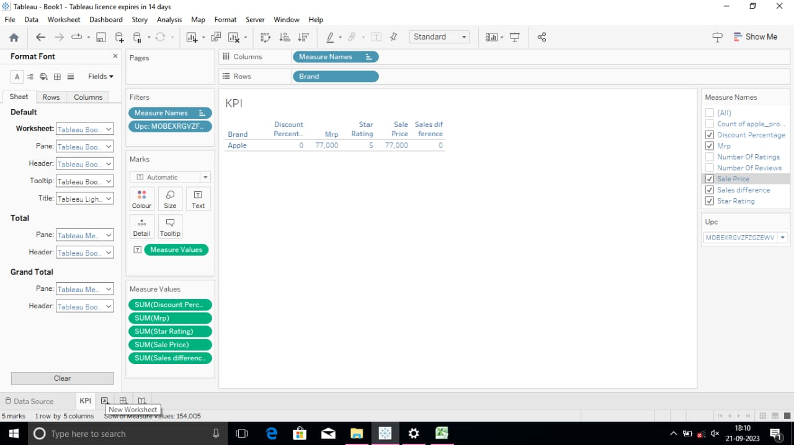

Activity 1.2: Model Specification

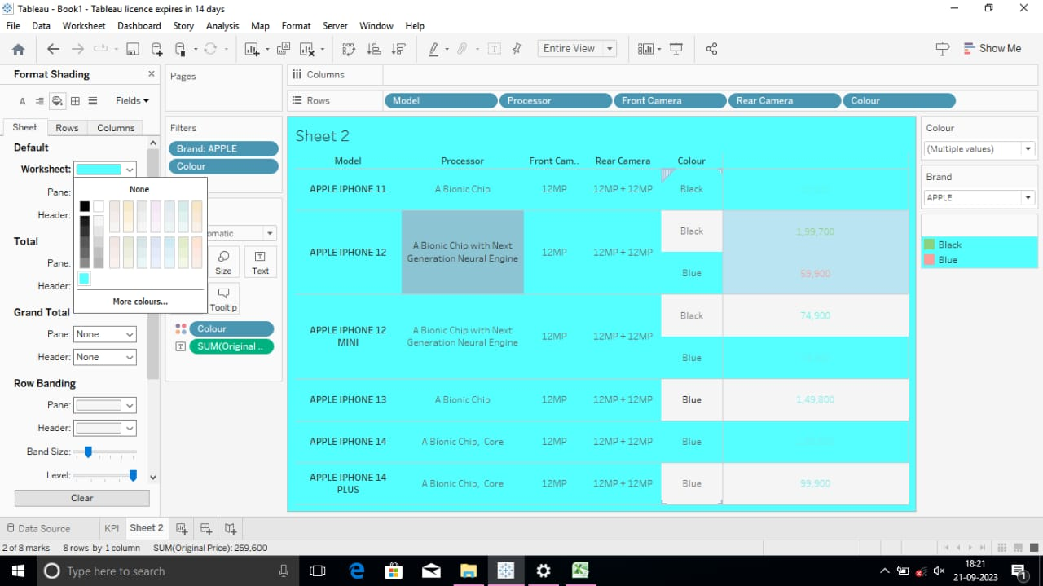

Activity 1.3: Battery type

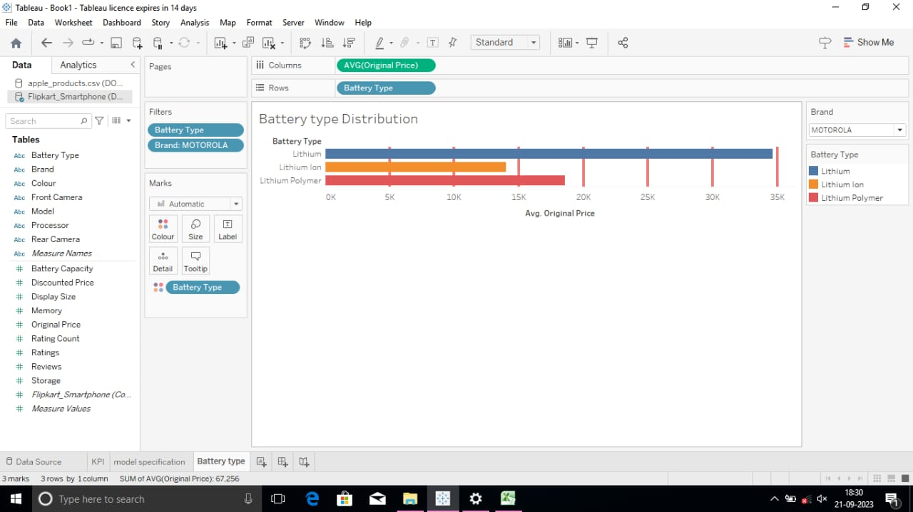

Activity 1.4: Brand Price Comparision

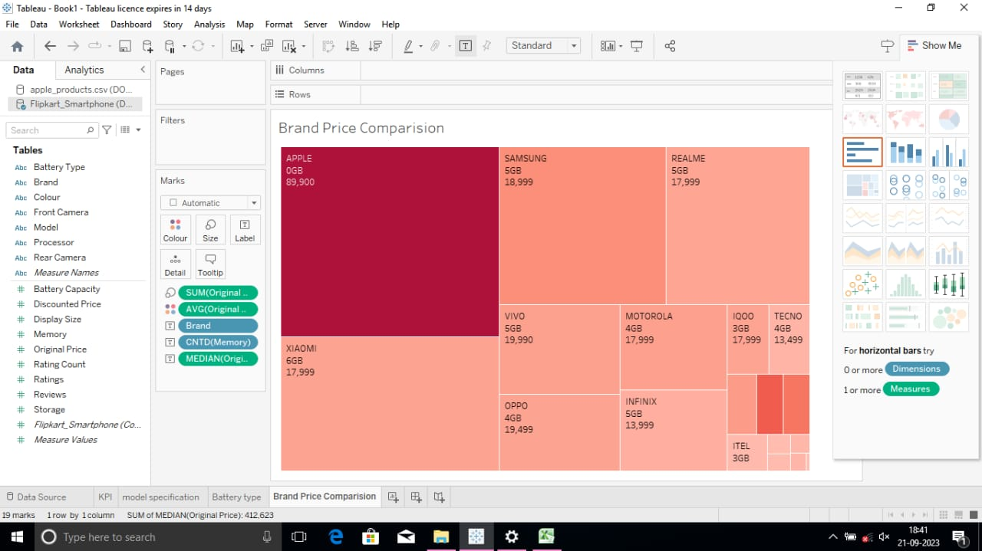

Activity 1.5:Model-share

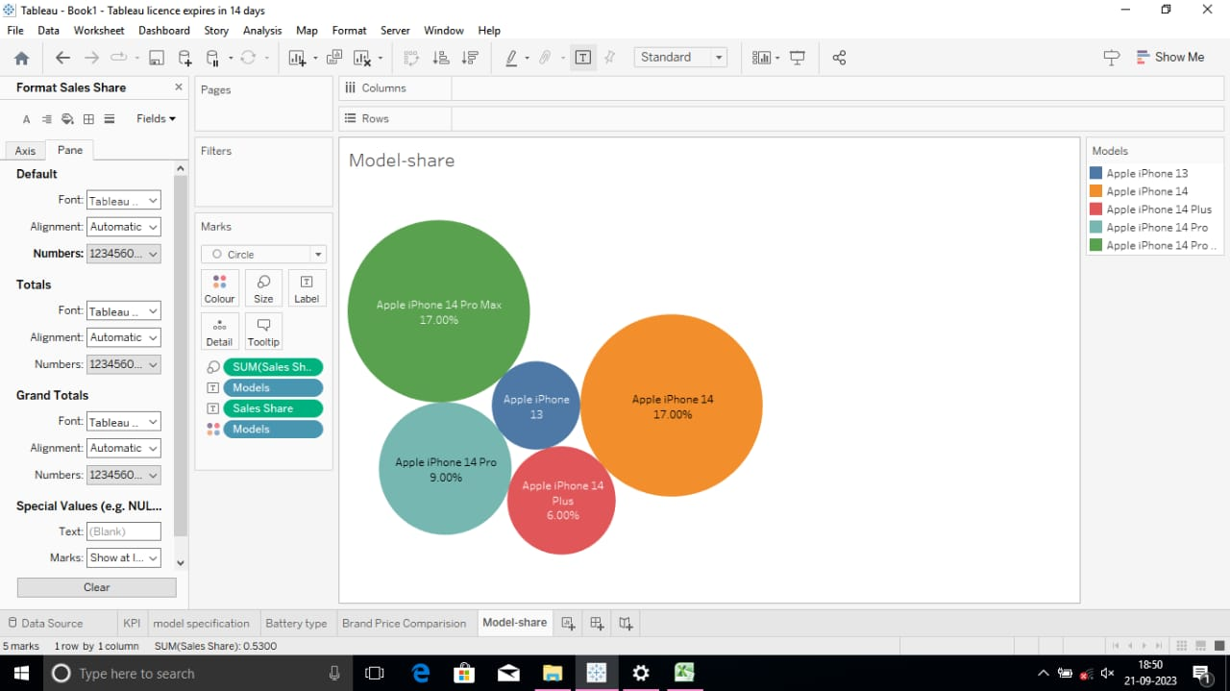

Activity 1.6: Country wise best selling smartphone

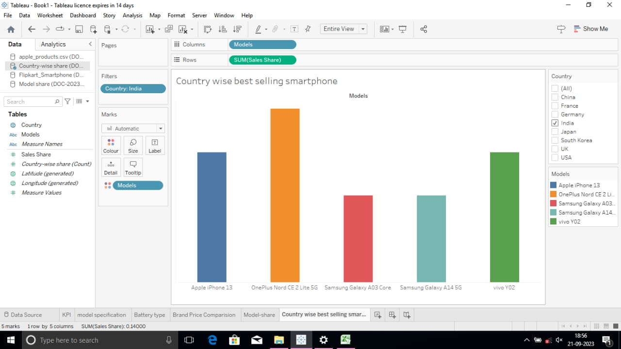

Activity 1.7: Quarterly-share

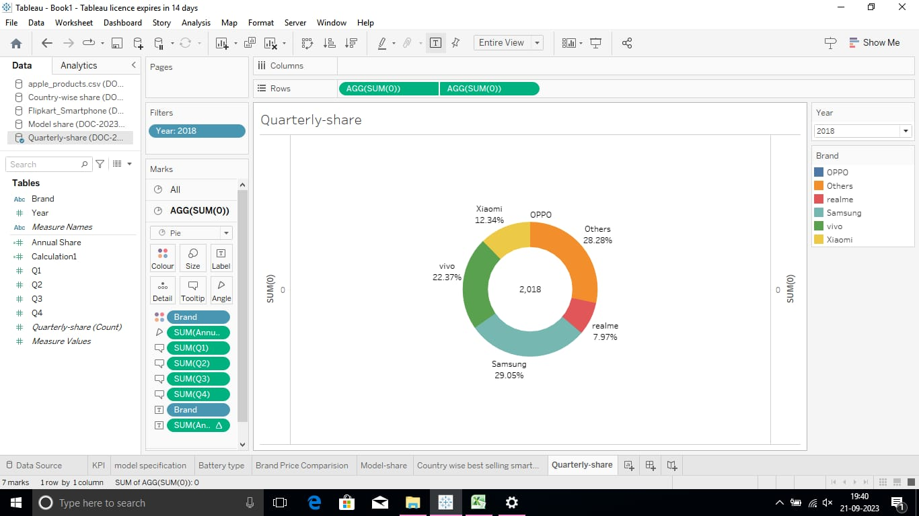

Activity 1.8:Annual Revenue

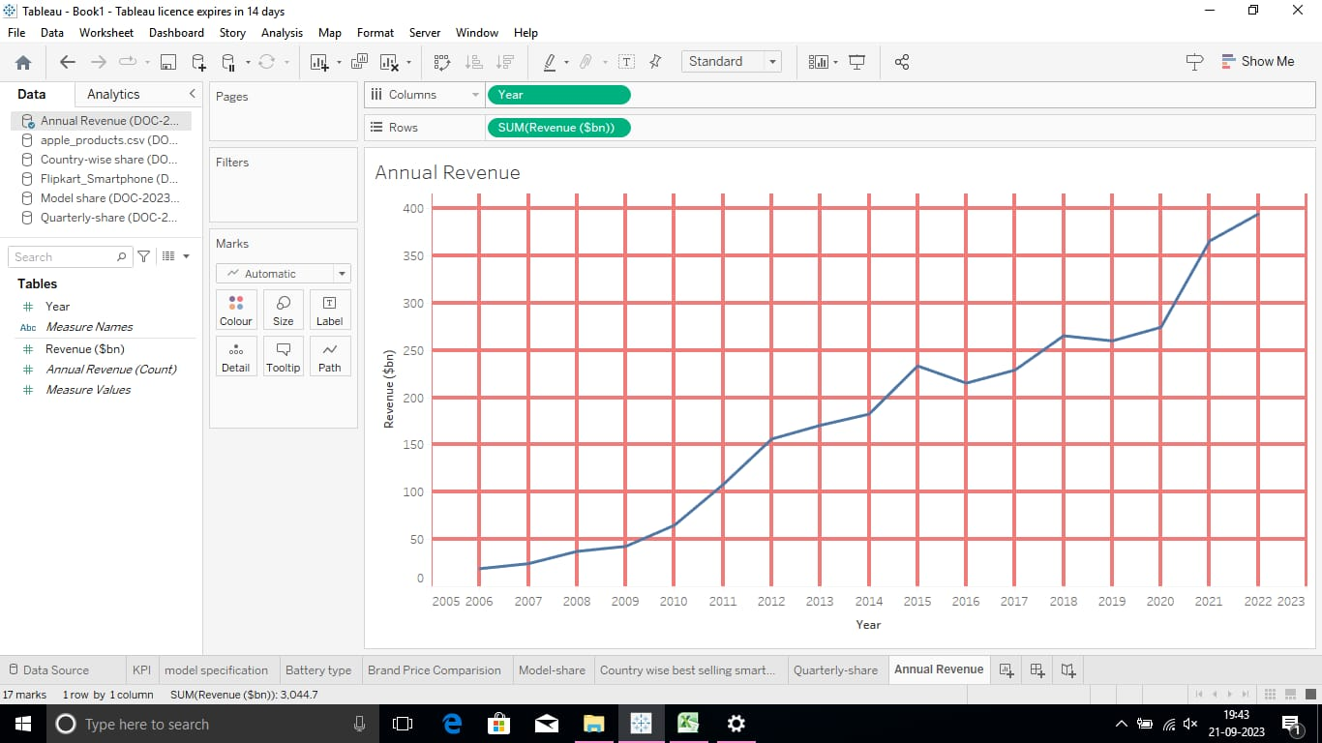

Activity 1.9: Global Market Share

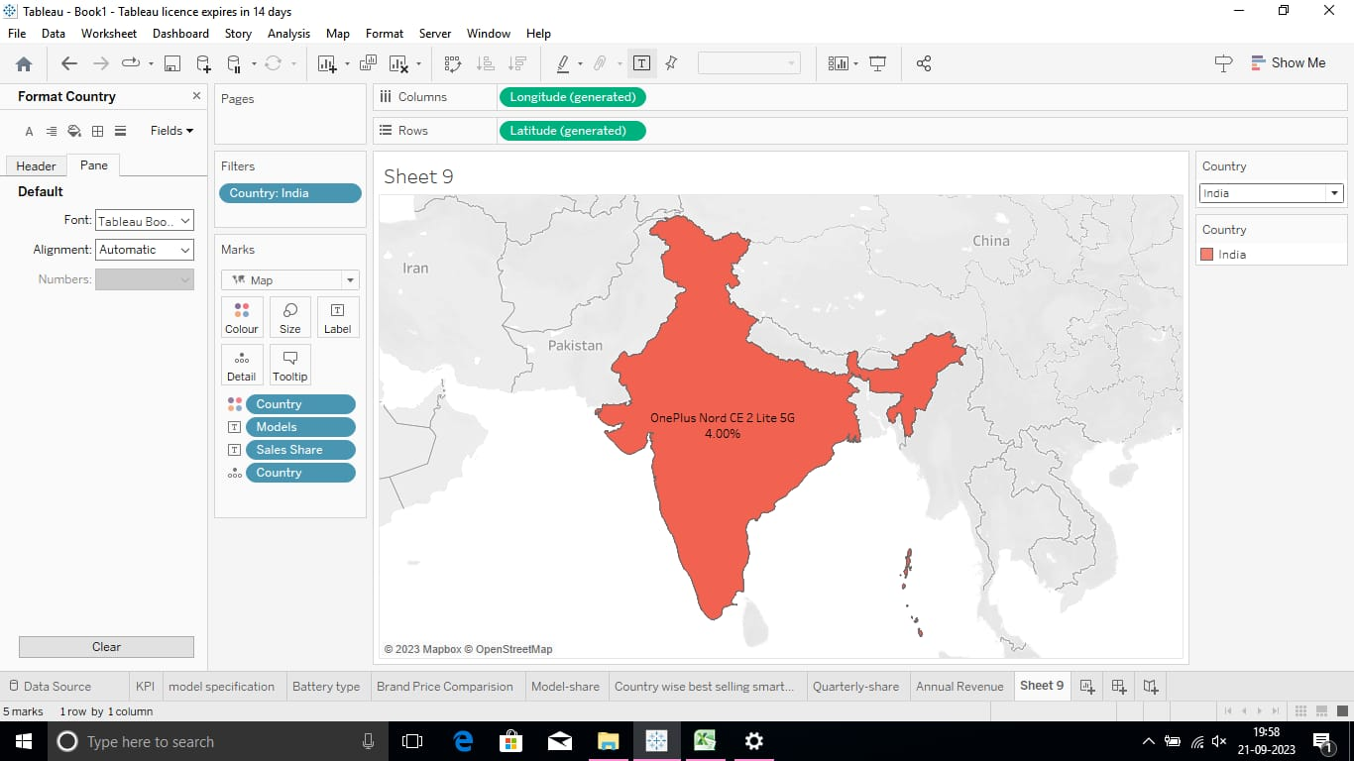

Activity 1.10: KPI 2

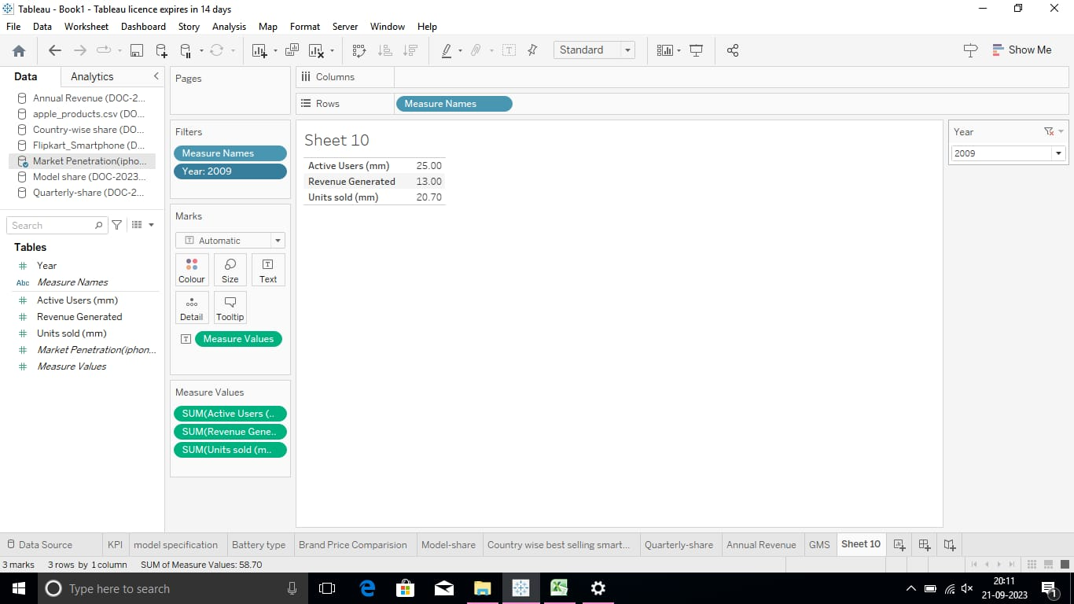

*Milestone 5: Dashboard*

A dashboard is a graphical user interface that displays information and data in an organized, easy-to-read format.

Activity 1- Responsive and Design of Dashboard

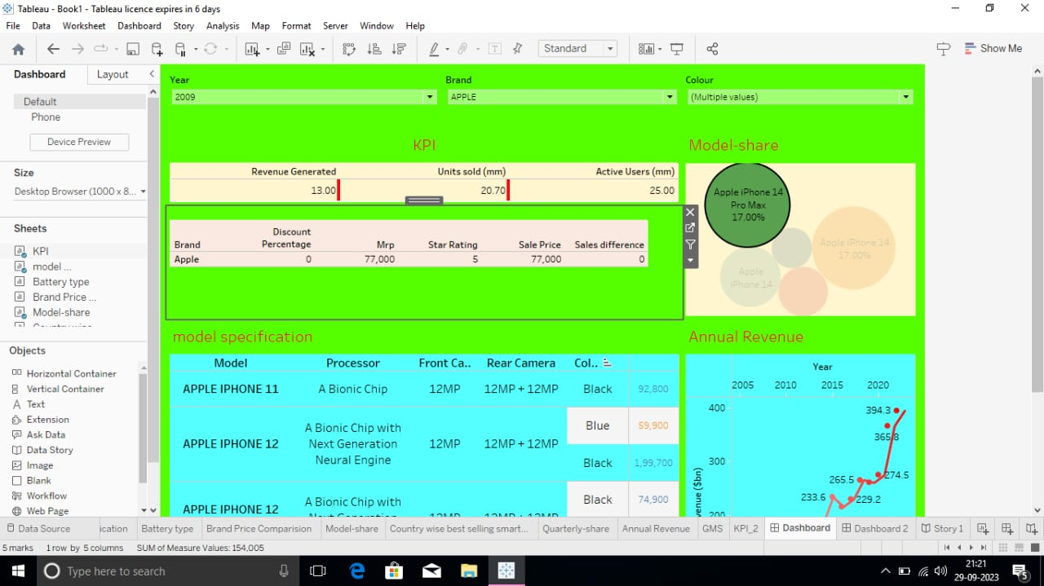

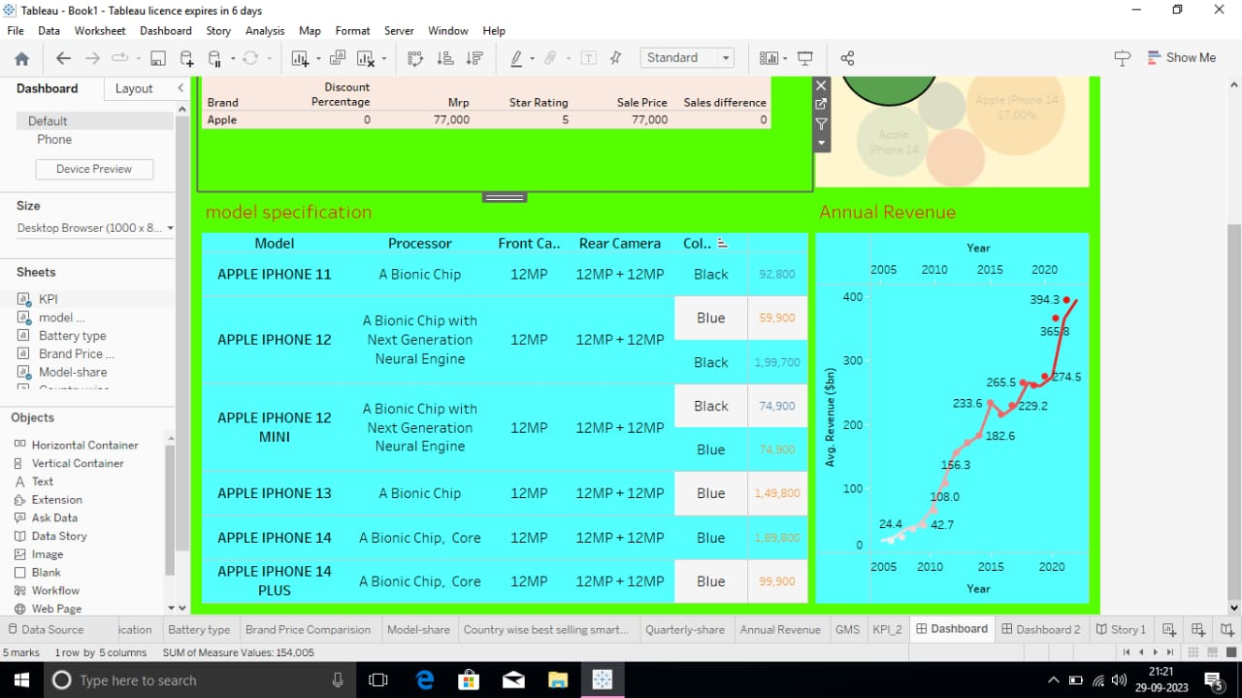

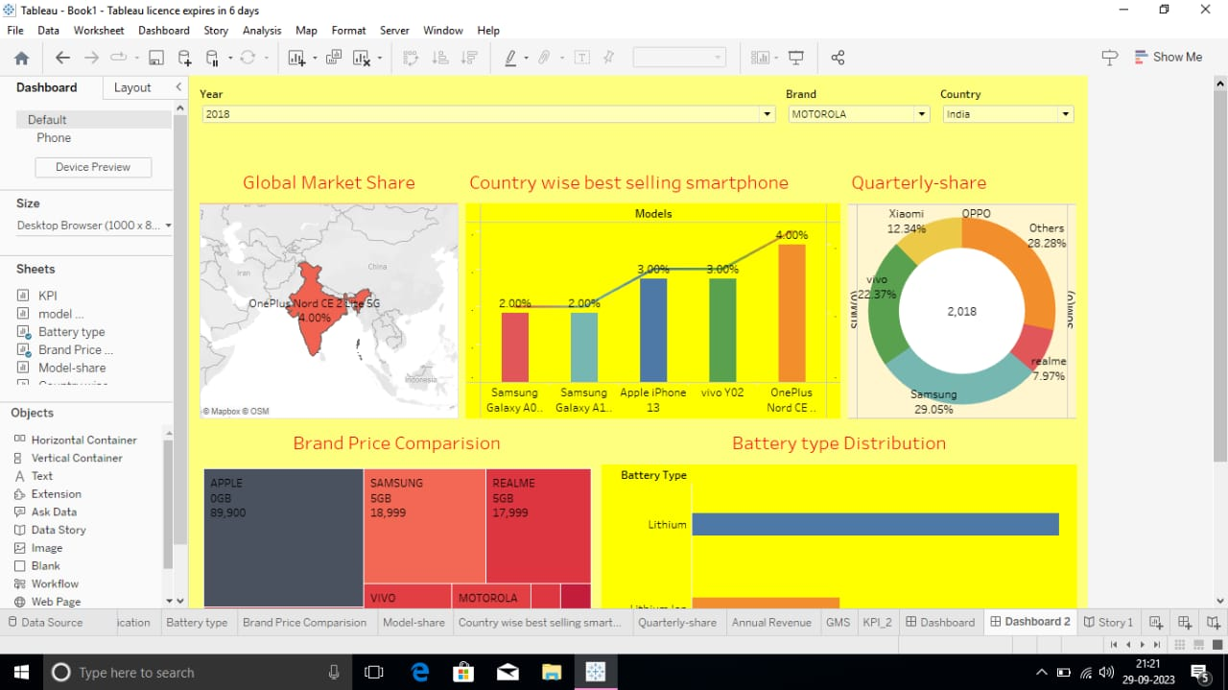

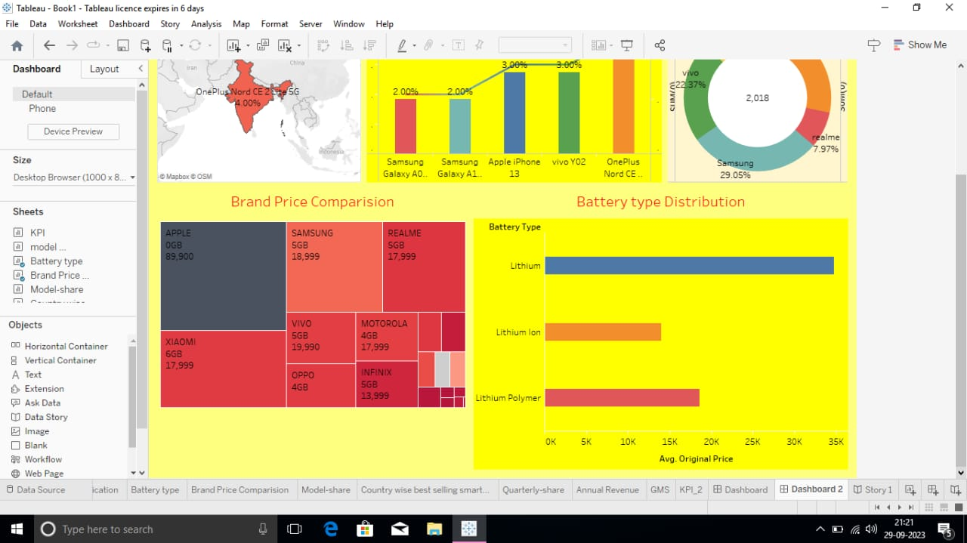

*Milestone 6: Story*

Activity 1: Number of Scenes of Story

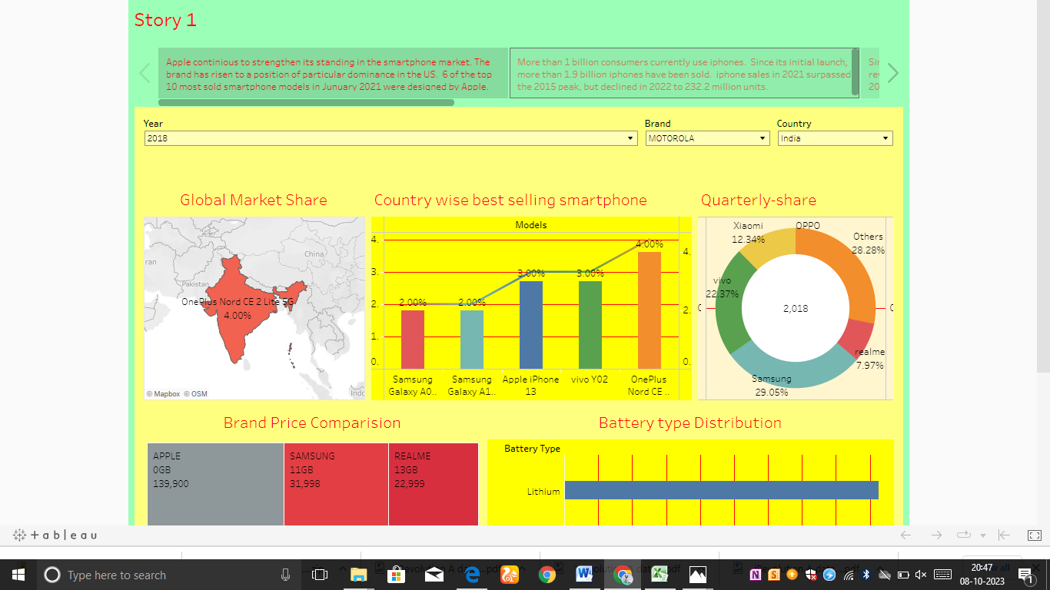

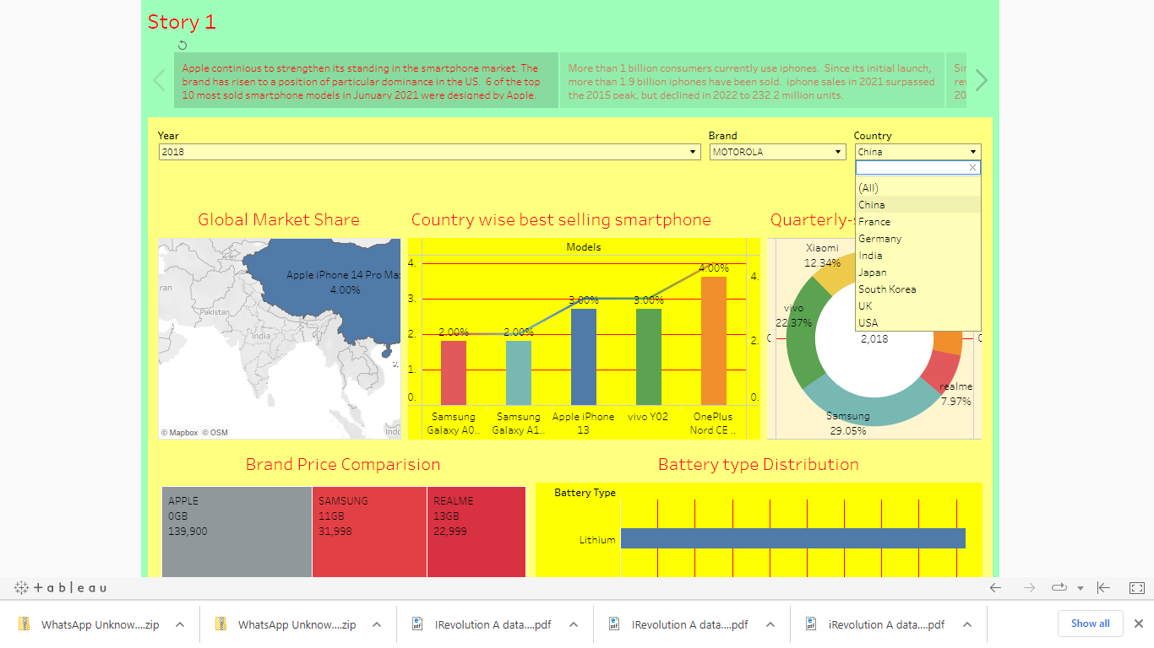

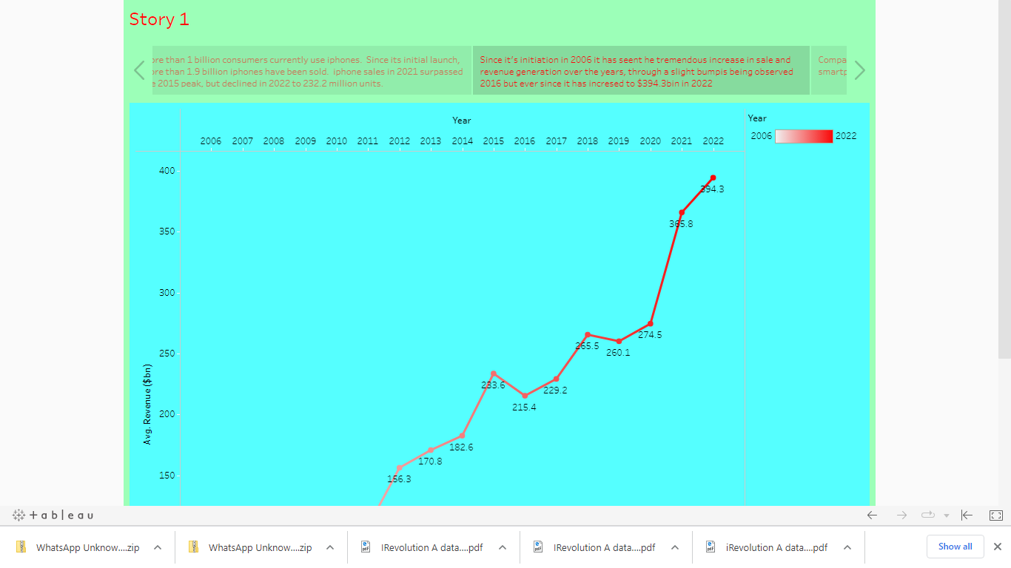  


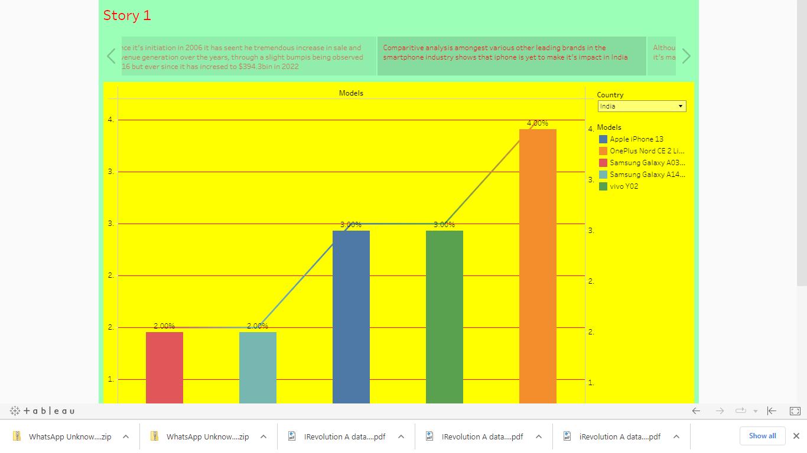

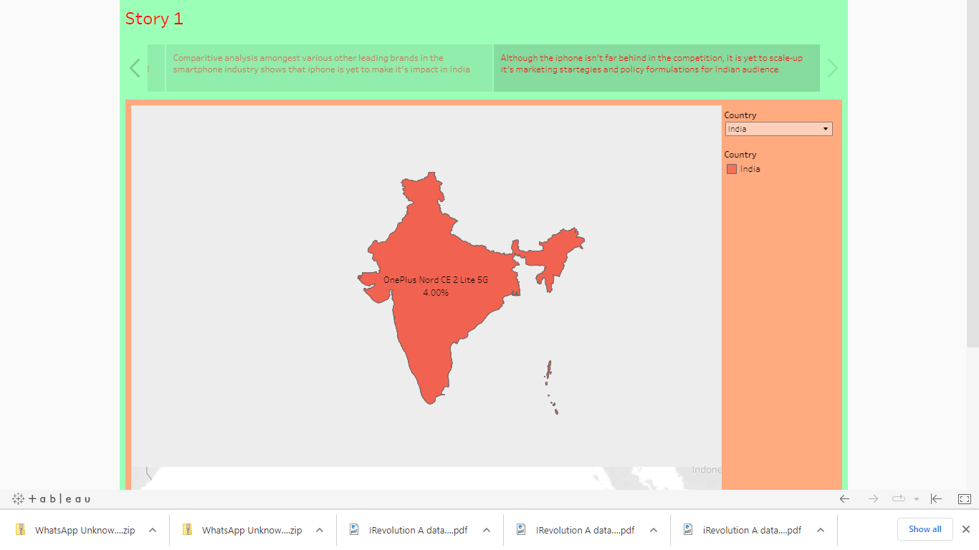

*Milestone 7: Performance Testing*

Activity 1

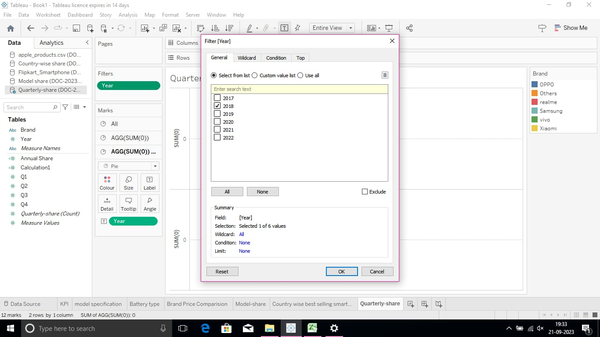



*Milestone 8: Publishing*

Dashboard 1 Link

<https://public.tableau.com/views/dashboad1_16955467587160/Dashboard?:language=en-US&:display_count=n&:origin=viz_share_link>

Dashboard 2 Link

<https://public.tableau.com/views/dashboad2_16955472354760/Dashboard2?:language=en-US&:display_count=n&:origin=viz_share_link>

Story

<https://public.tableau.com/views/STORY1_16957213764920/Story1?:language=en-US&:display_count=n&:origin=viz_share_link>